Name : SUNDEEP A SRN : PES1UG20CS445

Roll No : 48 Subject : DBMS

ScreenShot 1: Screenshot of database with the table – ‘train’ before populating it.

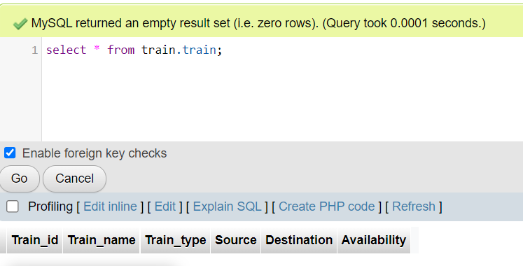

ScreenShot 2 : Screenshot of the User Interface.

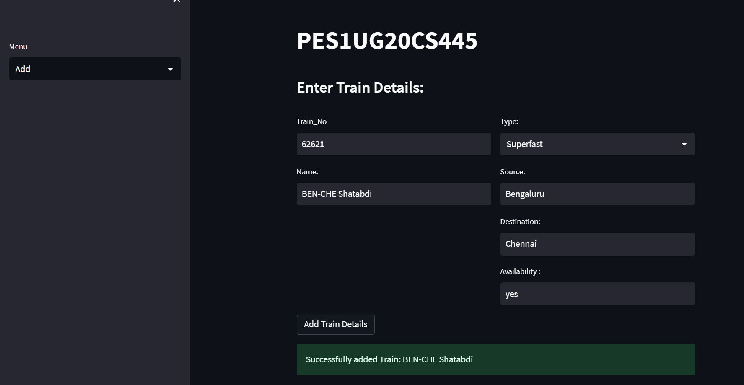

ScreenShot 3 : Screenshot of the 3 records in the train table from MySQL.

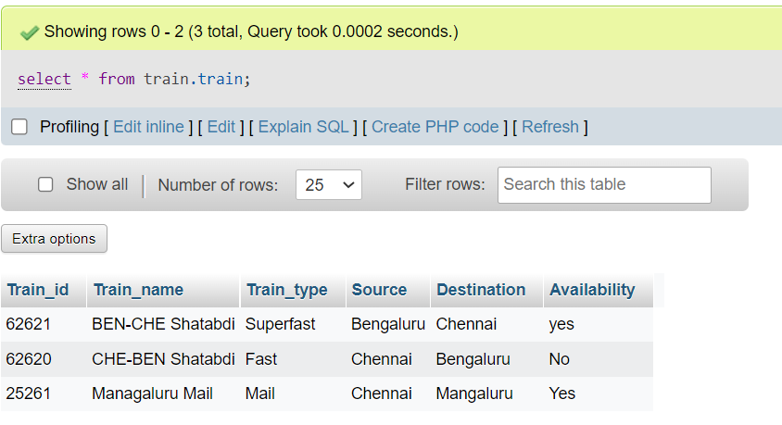

ScreenShot 4 : Screenshot of the same 3 records visualised in the User Interface

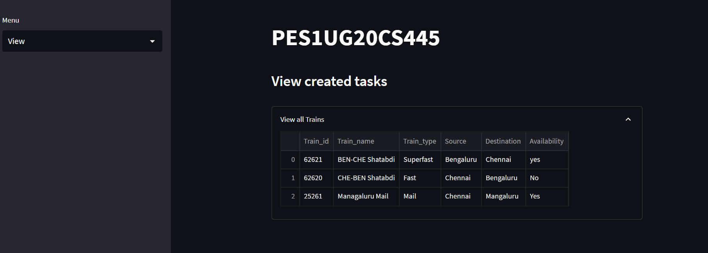

ScreenShot 5 : Screenshot of Updated Train_No 62620 in the User-Interface

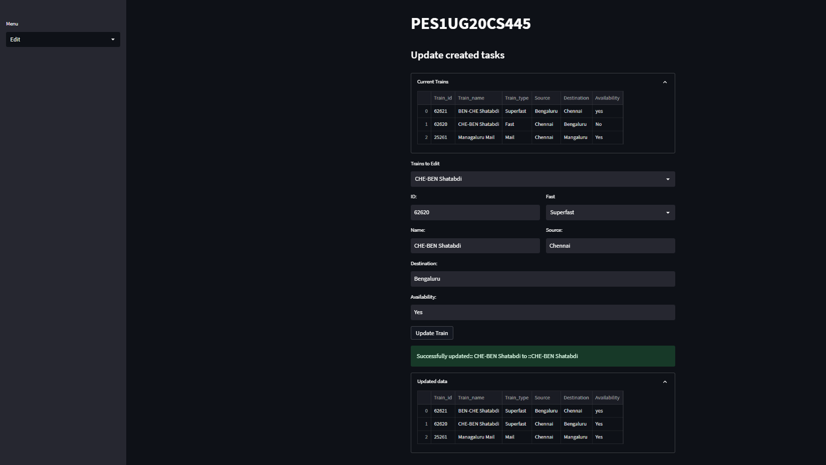

ScreenShot 6 : Screenshot of User-Interface after the Train_No 25261 has been deleted.

